Micah House Missional Vision Dec 2022
The Vision for Micah House Campus Ministry
Our goal is to create an intentional Christian community where people experience Jesus and his transformation. Our focus will be with students of Trent, and we believe that God has a big plan for campus ministry here. We will work with the Intervarsity Ministry currently running at Trent and our goal is to support their mission in sharing Jesus with the Trent student body. Micah house will be a residence for up to 5 students and our goal is to invest deeply in these students, inviting them to grow as followers of Jesus and as leaders in his Kingdom. We build authentic and meaningful relationships in order to demonstrate the love God has for everyone and to earn the right and respect needed to be a positive influencing force. We go deep with God, we go deep with each other, and we go out on mission together, serving others and helping them get connected with Jesus.

The Vision for Geneva’s Missional Houses
We want to create loving, living spaces for students where they will be intentionally discipled and mentored in the ways of following Jesus and living out his mission for the world.

The Model

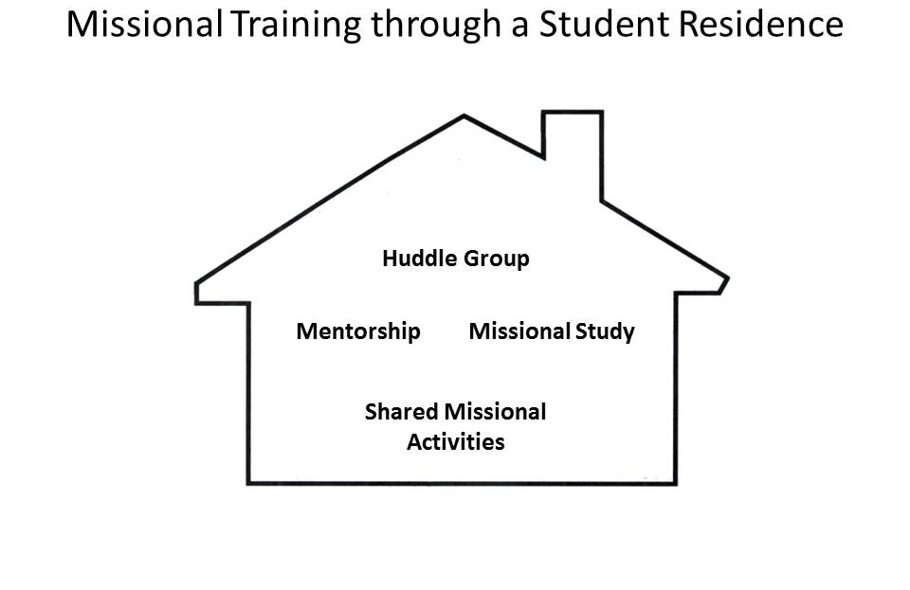

Our model is designed to provide missional training through a student residence. This training will have four components:
  - Huddle group
    - Residents will develop a daily rhythm of Scripture meditation and prayer, making use of a huddle journal to record their reflections.
    - Each week residents will gather for a 90 minute huddle to share how God has been speaking to them, how they are living missionally, and how they would like to be prayed for.
  - Individual mentorship/coaching
    - The missional house leader will regularly invest in the resident to nurture a missional lifestyle.
  - Group training study sessions
    - Regular group sessions will be provided to instruct residents in missional theory and to inspire residents to live out God’s mission in their everyday lives.
  - Shared missional activities
    - Residents will work together to plan various activities designed to provide them with missional experiences. The particulars of these activities will be defined by the residents and will flow out of their specific context and networks.

Objectives
- The specific objective of the missional house model is to help residents understand what it means to be missional and to provide experiences in missional living.

Goals
- Missional Living
  - Students will invest in their housemates by caring for each other’s emotional, spiritual, and physical needs.
  - Students will invest in their personal relationship with God through daily times of personal prayer and bible reflection.
  - Students will invest in their friends and acquaintances through relational evangelism.
- Missional Understanding
  - Students will participate in a weekly discipleship group which includes reflection on daily devotional times and weekly readings of missional materials.
  - Students will receive regular mentorship by missional home leaders.
- Missional Activity
  - Students will plan and participate in weekly events designed to build community with friends who are not following Jesus.

Support
- Discipleship through mentorship.
  - With support from Momentum Ministries resources will be provided to keep help facilitate the above goals
  - With support from Trent Chaplaincy (Ben Peltz) and Intervarsity Ministries we plan to provide opportunity for discipleship with practical life training to ensure strong community within the house.
  - With support from the local church we plan to be involved by providing communal meals and social gatherings to invite other students to.

